ATOMQUEST HACKATHON 1.0
Problem Statement
In-House Goal Setting & Tracking Portal
Technical Documentation |v1.0|May 2026

Contents
1. Project Overview 2
2. Technology Stack 3
3. System Architecture 3
4. Data Model 4
5. User Roles & Workflows 5
6. Business Rules & Validation 6
7. Progress Score Computation 6
8. Reporting & Governance 7
9. Good-to-Have Features Implemented 7
10. Deployment & Infrastructure 8
11. Demo Login Credentials 8

1. Project Overview
The Goal Portal is a full-stack web application built for the AtomQuest Hackathon that digitises the complete employee goal lifecycle — from goal creation and manager approval through quarterly check-ins to achievement reporting. It replaces fragmented spreadsheet-and-email workflows with a structured, audit-ready platform accessible by Employees, Managers, and Admins.

1.1 Problem Being Solved
- No real-time visibility into team progress for managers
- Employees lack clarity on how individual goals connect to org priorities
- HR teams piece together data manually at appraisal time
- No enforcement of weightage rules or goal validation
- No audit trail for changes made after approval

1.2 Solution Summary
A Next.js 14 web portal backed by a MySQL database (via Prisma ORM) that enforces goal-setting rules, manages an approval workflow, supports quarterly check-ins, and produces exportable achievement reports.

2. Technology Stack

Layer | Technology | Rationale
Frontend | Next.js 14 (App Router) + React | Server components, file-based routing, SSR/CSR hybrid
Styling | Tailwind CSS | Utility-first, no build overhead, responsive out of the box
Backend | Next.js API Routes (TypeScript) | Co-located with frontend, no separate server needed
ORM | Prisma | Type-safe DB access, auto-generated client, migration support
Database | MySQL (PlanetScale / Railway) | Relational integrity for goal-sheet-user hierarchy
Auth | Custom session (requireUserSession) | Lightweight; github oauth app
Hosting | Vercel (frontend) + TiDB(DB) | Serverless, auto-scaling, free tier covers demo load
Export | xlsx / csv generation in API routes | Achieves CSV & Excel export requirement natively

3. System Architecture
The portal follows a monolithic Next.js architecture with clear separation between client components (interactive UI), server components (data fetching), and API routes (business logic + DB access). Prisma acts as the single source of truth for all DB operations.
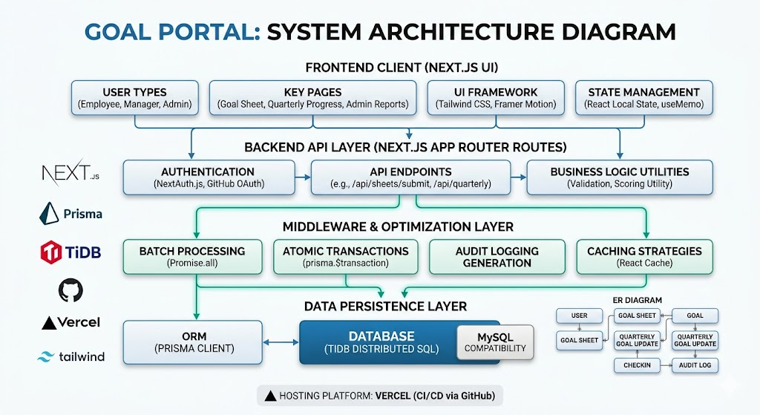

3.1 High-Level Layers
Layer | Components | Responsibility
Presentation | React Client Components, Tailwind UI | Employee / Manager / Admin dashboards, forms, charts
API | Next.js Route Handlers (/api/**) | Auth checks, business rules, DB orchestration
Data Access | Prisma Client + Transactions | Type-safe queries, cascading deletes, audit writes
Database | MySQL — 8 tables | Persistent storage of users, cycles, goals, check-ins, audit logs

4. Data Model
The schema is defined in Prisma and maps directly to MySQL tables. All foreign keys are enforced at the DB level.

Model | Key Fields | Notes
User | id, email, role, managerId (self-ref) | Supports Employee / Manager / Admin roles; manager hierarchy via self-join
Cycle | id, name, kind, year, opensAt, closesAt | Controls which phase is active (GOAL_SETTING, Q1–Q4)
GoalSheet | employeeId, cycleId, managerId, status | Unique per (employee, cycle); status: DRAFT → SUBMITTED → APPROVED / REWORK
Goal | sheetId, title, thrustArea, uomType, direction, target, weightPct | Max 8 per sheet; weights must sum to 100%; min 10% each
QuarterlyGoalUpdate | goalId, period, plannedTarget, actual, progressScore | One row per (goal, quarter); score computed server-side
CheckIn | sheetId, period, managerId, comment, managerRate | One per (sheet, quarter); locks employee update window
SharedGoalDefinition | title, target, primaryOwnerId | Pushed by Admin/Manager; recipients get read-only title+target
AuditLog | entity, entityId, action, actorId, detail | Append-only; written inside transactions with every state change

5. User Roles & Workflows

5.1 Employee Workflow
- Log in and land on the Goal Sheet dashboard
- Add up to 8 goals, assign Thrust Area, UoM, Target, and Weightage
- System validates: total weight = 100%, each goal >= 10%
- Submit sheet — status moves to SUBMITTED
- If returned (REWORK), edit and resubmit
- Once APPROVED, goals are locked; only actuals can be updated quarterly
- Each quarter: log Actual Achievement and select progress status

5.2 Manager Workflow
- View all direct reports' submitted sheets
- Review goals inline — can edit targets and weightages before approval
- Approve (locks sheet) or return for rework with comments
- Each quarter: open check-in module, view Planned vs Actual per employee
- Add structured check-in comment; optionally rate the discussion

5.3 Admin Workflow
- Manage Cycles — set open/close windows for each phase
- View completion dashboard — who has/hasn't done check-ins
- Unlock individual goals for correction post-approval
- Push Shared Goal Definitions to multiple employees
- Export Achievement Report as CSV or Excel
- View full Audit Log

6. Business Rules & Validation

Rule | Enforcement Point | Detail
Max 8 goals per sheet | API + UI | Reject submission if goals.length > 8
Min 10% weight per goal | API + UI | Each goal's weightPct must be >= 10
Total weight = 100% | API + UI | Sum of all weightPct across sheet must equal 100
Goals locked on approval | API | readOnlyTitleTarget flag set; updates blocked by status check
Shared goal title/target read-only | Schema + API | readOnlyTitleTarget = true on linked goals
One check-in per (sheet, quarter) | DB unique constraint | @@unique([sheetId, period]) on CheckIn
One update per (goal, quarter) | DB unique constraint | @@unique([goalId, period]) on QuarterlyGoalUpdate
Progress score formula | API | MIN: actual/target; MAX: target/actual; ZERO: actual==0 ? 1 : 0; TIMELINE: date diff

7. Progress Score Computation
Progress scores are computed server-side on every quarterly update. They are stored as a decimal (0–100) for tracking only and do not constitute ratings.

UoM Type | Direction | Formula | Example
Numeric / % | MIN_HIGHER_BETTER | min(actual / target, 1.2) × 100 | Actual 90, Target 100 → score 90
Numeric / % | MAX_LOWER_BETTER | min(target / actual, 1.2) × 100 | Actual 80, Target 100 → score 100 (under budget)
Timeline | N/A | (1 - daysDiff / totalDays) × 100 | Completed 5 days before deadline → high score
Zero-based | N/A | actual === 0 ? 100 : 0 | Zero safety incidents → 100%

8. Reporting & Governance

8.1 Completion Dashboard
Available to Admin and Manager. Shows per-employee check-in status for any selected quarter. Metrics include: completion rate %, pending count, total achievement %, highest performer.

8.2 Achievement Export
Admin can download a CSV or Excel file containing: Employee Name, Department, Goal Title, Thrust Area, UoM, Target, Actual, Progress Score — one row per goal per employee.

8.3 Audit Trail
Event | Logged Fields
Goal sheet submitted | entity=GOAL_SHEET, action=SUBMIT, goal count, total weight
Sheet approved | entity=GOAL_SHEET, action=APPROVE, approvedBy, timestamp
Sheet returned for rework | entity=GOAL_SHEET, action=REWORK, comment
Goal unlocked by admin | entity=GOAL, action=UNLOCK, reason
Quarterly actual updated | entity=GOAL_UPDATE, action=UPDATE, old value, new value

9. Good-to-Have Features Implemented
Analytics Module
The Admin Reports page includes: completion rate donut chart, total achievement %, highest performer card, and a quarter-on-quarter bar chart. Goal distribution by Thrust Area is available via the achievement export.

Escalation Module (Architecture-ready)
Escalations on Manager Portal, if no action is taken then in three days then the goal sheets is automatically removed from the queue.

10. Deployment & Infrastructure

Component | Service | Cost Tier
Next.js App | Vercel (Hobby / Pro) | Free for demo; $20/mo Pro for production
MySQL Database | TiDb Cloud | Free tier; scales per query volume
File Storage (exports) | In-memory streaming | No storage cost; exports generated on request
Auth Sessions | Server-side cookie sessions | No third-party cost

Total estimated demo cost: $0 (free tiers). Production estimate: ~$20–40/month for 200 active users.

11. Demo Login Credentials
Role | Email | Password | Access
Admin | admin@goalportal.com | Admin@123 | Full portal access, reports, audit log, cycle management
Manager | manager@goalportal.com | Manager@123 | Team dashboard, approval workflow, check-ins
Employee | employee@goalportal.com | Employee@123 | Goal creation, submission, quarterly actuals

Live demo: https://goal-setter-and-tracker.vercel.app
Github repo: https://github.com/PalakPrajapati346/Goal-Setter-and-Tracker.git

